Garuda Research Institute

Tools for HRM&D

Providing people with opportunities

Creating Balance Between People

Same Map
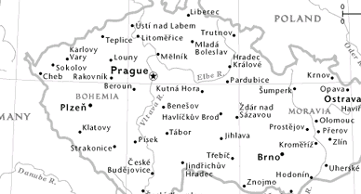

Shared language

Reliable instruments

The Head-Heart-Leg Model



Getting ideas


Selling ideas



Implementing
Ideas

Personality and behavior

Getting ideas
System flexibility
Comprehensiveness
Abstract thinking
Willingness to take risks
Self control

Selling ideas
Empathy
Social contact
Social flexibility
Backing
Trust - Openness

Implementing Ideas
Competition
Influence
Self-confidence
Independence
Psychological strength
Physical energy

Personality and behavior

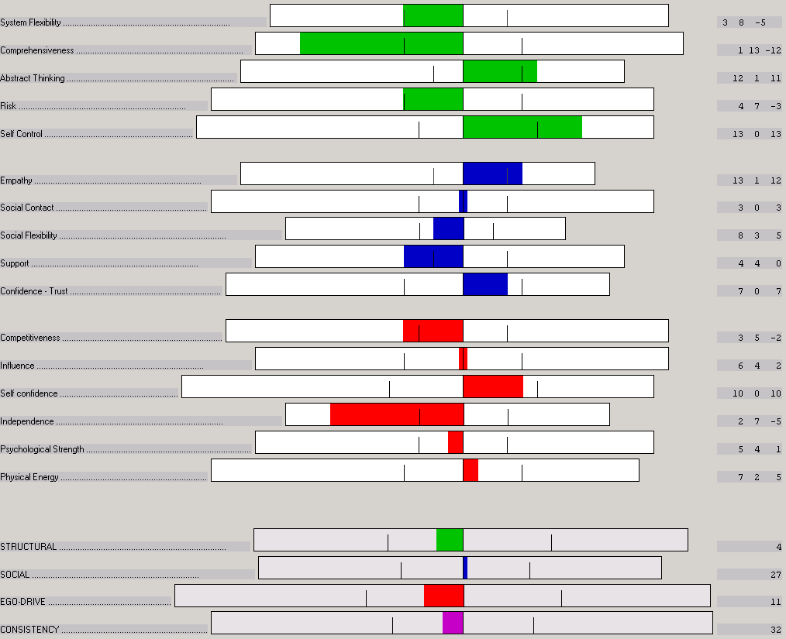

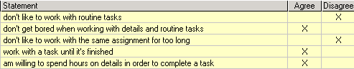

Personality and behavior

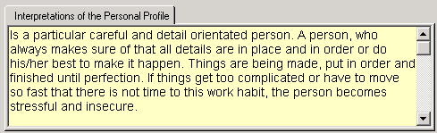

Focus Areas

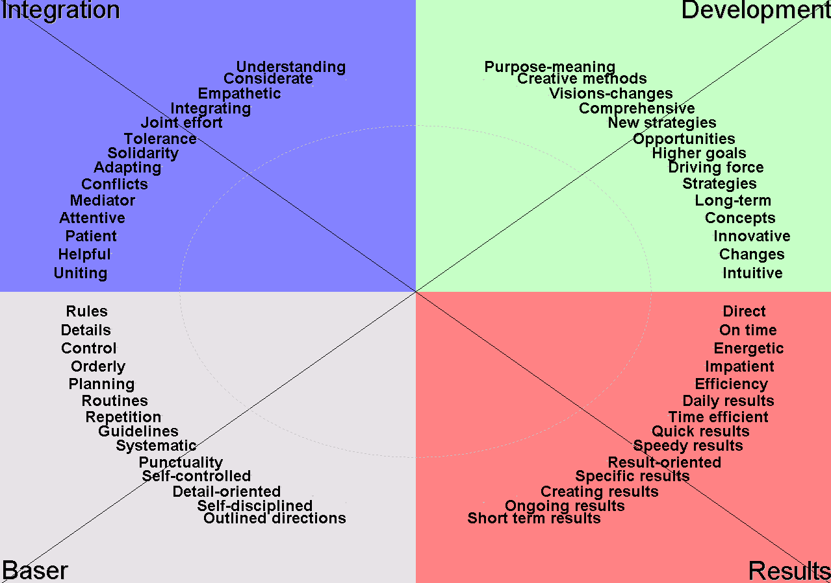

Focus Areas

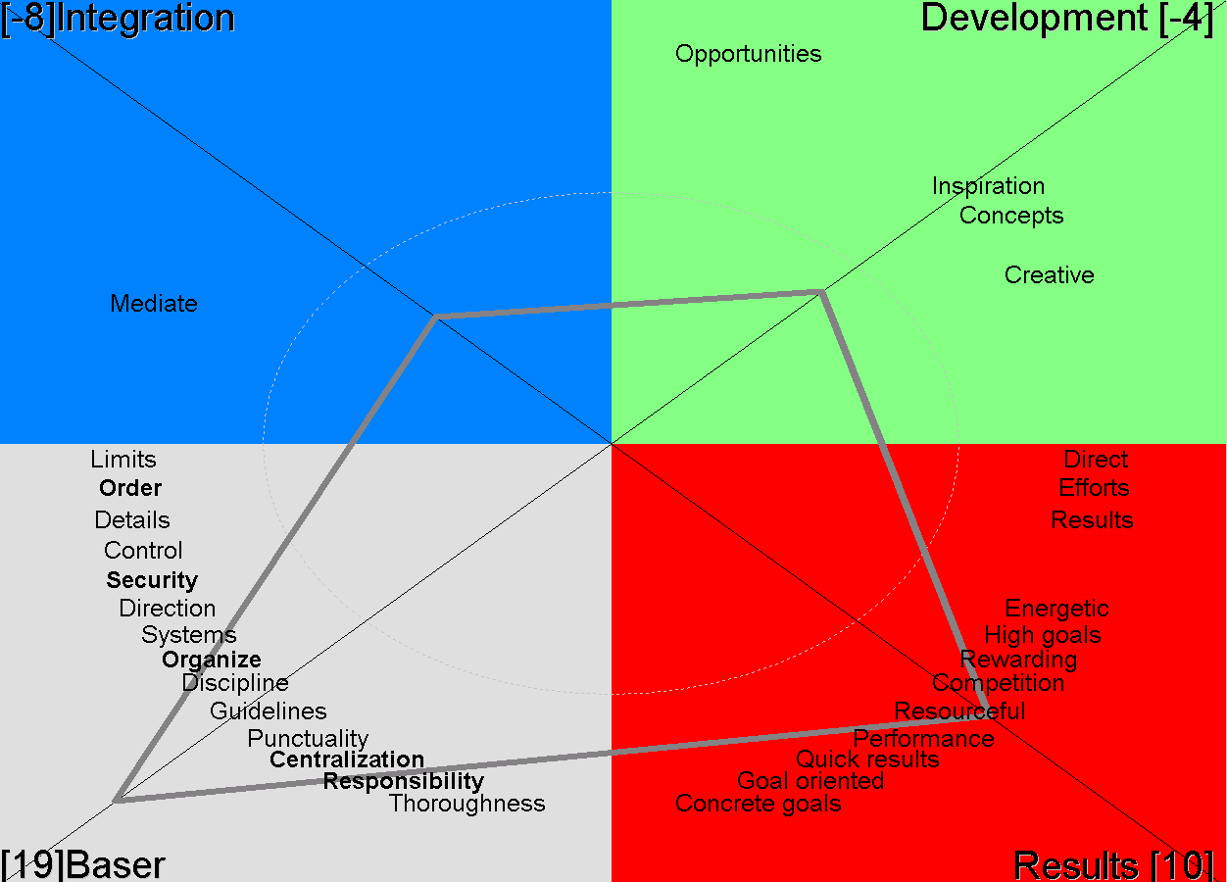

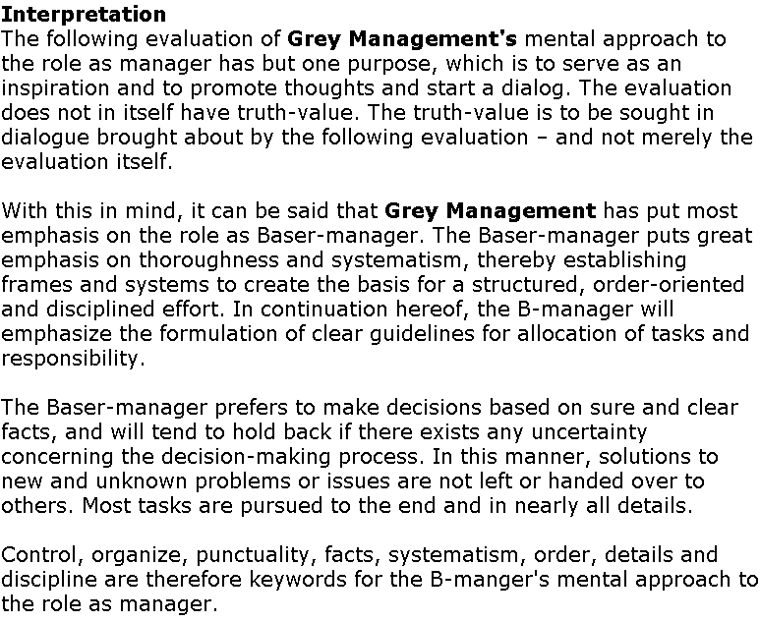

Management Behavior Level

Risk

Details Comprehensive

Security

Management Behavior Level

Trust

Indifference Empathy

Distrust

Management Behavior Level

Influence

Timid Self-confidence

Submissive

Organizational level – Organization Culture

Competence Culture
- Problem solving
- Direction - control

Social
Culture
- Involvement
- Communication

Implementing Culture
- Decision making
- Performance

Organizational level – Organization Culture

Direction
Concept

Problem solving

Conventional Creative

Rule direction

Organizational level – Organization Culture

Involvement
Active

Communication

Closed Open

Distrust

Organizational level – Organization Culture

Performance
Pro-active

Decision making

Centralization De-centralization

Re-active

Management behavior – Culture

Risk/Concept

Details/ Comprehensive/
Conventional Creative

Security/Rule

Management behavior – Culture

Trust/Involvement

Indifference/ Empathy/

Closed Open communication

Distrust/Passive

Management behavior – Culture

Influence/Pro-active

Timid/ Self-confidence/

Centralization De-centralization

Submissive/Re-active

Culture and Focus Areas

Concept Direction

Conventional
Creative

Rule Direction

Customer Relation Level

Competence
Relations

Products
Quality
Service

Social

Relations

Communication
Contact
Trust

Implementation

Relations

Delivery
Punctuality
Reliability

Customer – Culture Relations

Complexity

Concept

Conventional Creative

Rule

Importance
Customer – Culture Relations

Dependency
of Social relations

Involvement

Active

Communication

Closed Open

Passive

Importance

Customer – Culture Relations

Un-predictability

of implementation
problems
Performance
Pro-active

Decision making

Centralization De-centralization

Re-active

Importance

